BIBLIOTHERAPY TERMS

ASCA Classification: | Audience:
Personal Social | Elementary
Career Vocational | Secondary
Educational Academic

- Go to the SPU Library homepage: www.spu.edu/library
- Click on the SPU WorldCat and Beyond link in the left navigation area
- Click on the Search Classic Catalog link
- Click on the Search Classic Catalog link (this is repeated intentionally)
- Click on the Other Subject Headings link
- Enter one of the ASCA Classification terms listed above and click on Submit Search.

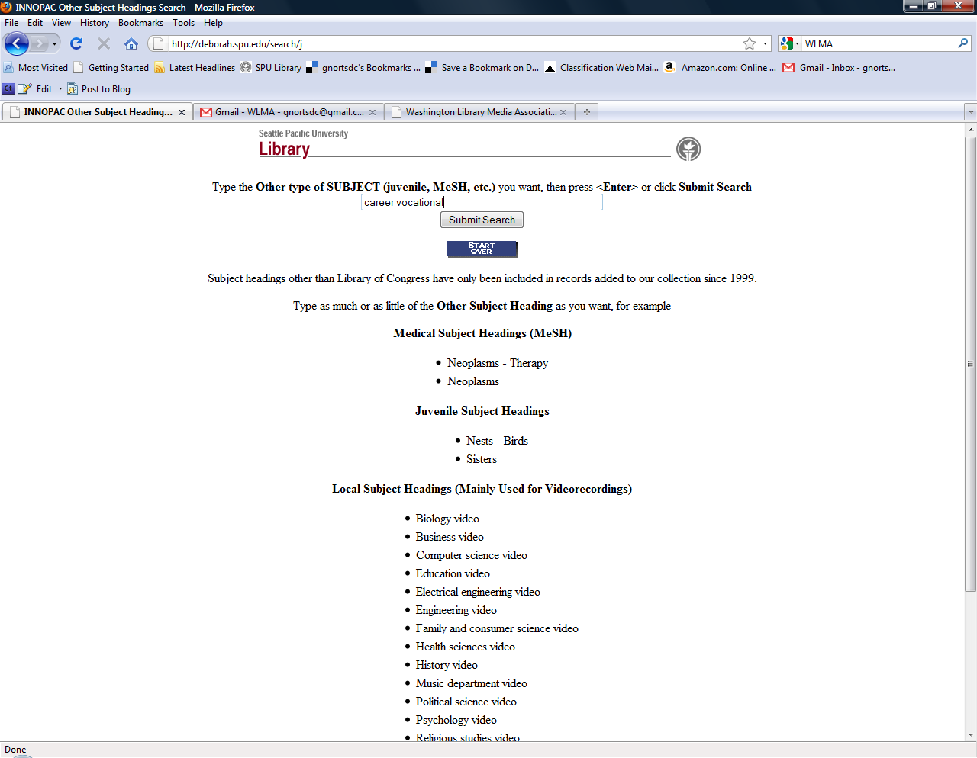

- Click on the link of a germane item
- Note the Location, Call Number, and Status of the book (Check Shelf = book is available).
- Also note that the ASCA Classifications and Audience appear as Local subj.
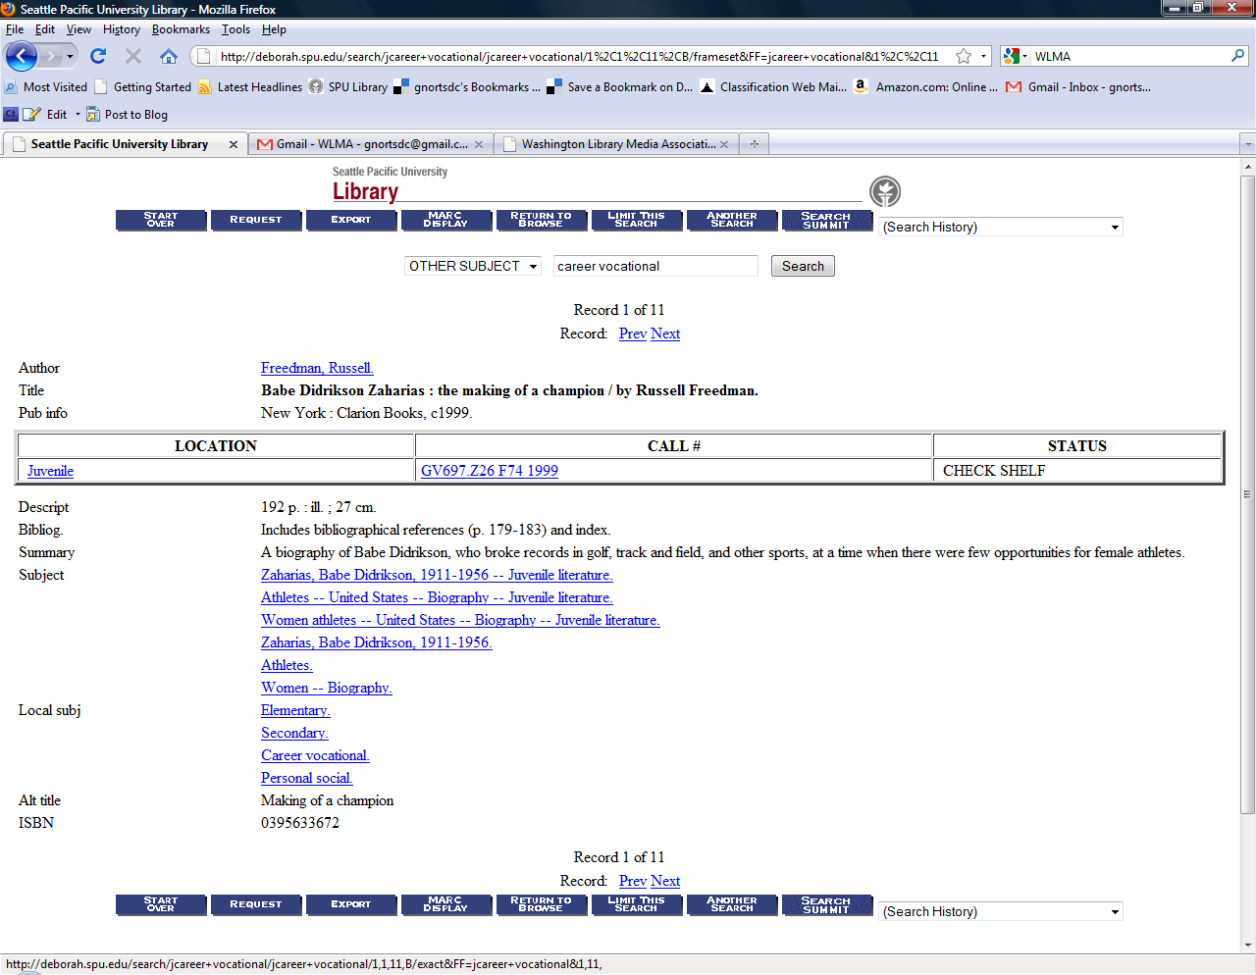

Finding bibliotherapy books using an ASCA Classification term and Audience:

- Go to the SPU Library homepage: www.spu.edu/library
- Click on Start Page link next to Search the “Classic” Catalog verbiage
- Click on Keyword
- Enter su=ASCA Classification term of choice and su=Audience term of choice and click on Search.

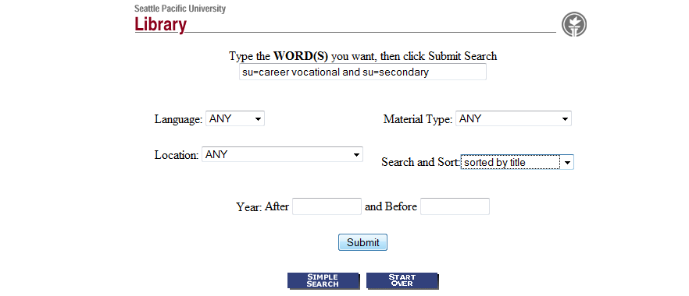

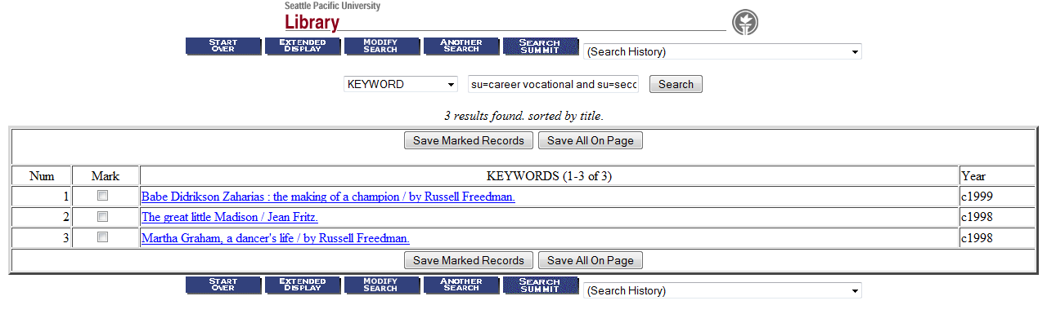
- You will receive a list of what is available.

