The ERIC Database has subject headings assigned to each article, which are called “DESCRIPTORS.” Descriptor Location: In the ERIC Database record below the citation information above the abstract.

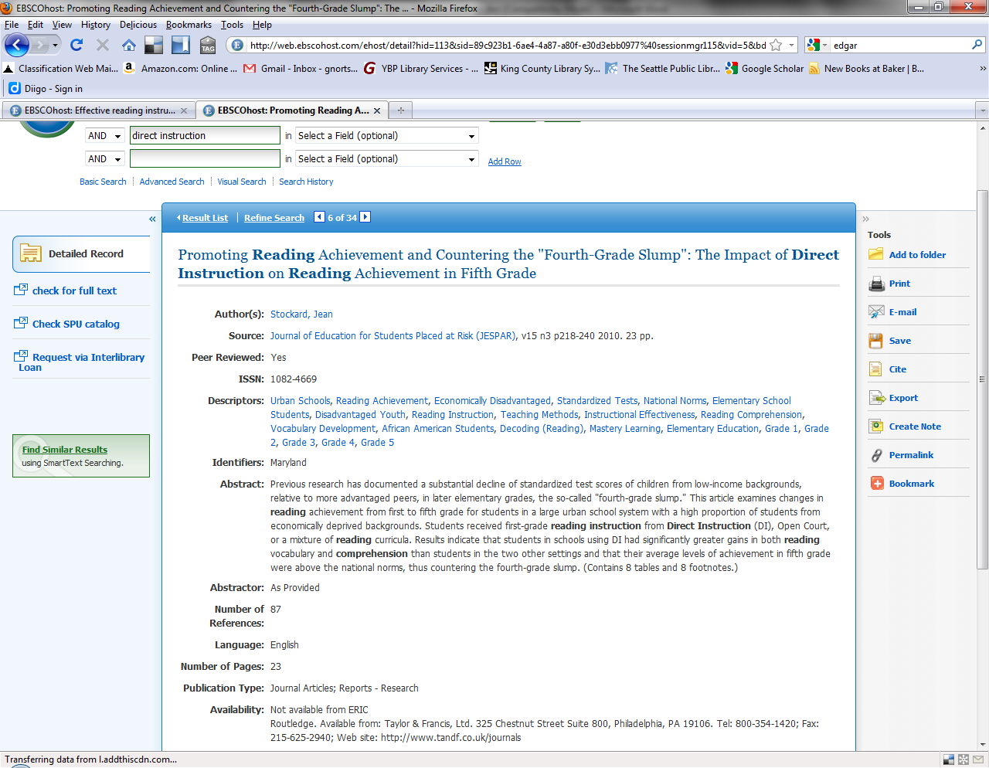

SUBJECT HEADING EXERCISE:
You can use these words to help you build an effective search. As you begin to search using keywords, keep track of your favorite descriptors by writing them in the boxes below. When you return to your search screen, use these database specific words to build a more effective search.

The PsycINFO Database has subject headings assigned to each article, which are called “SUBJECTS.” Subject Location: In the PsycINFO Database record below the citation information and the abstract.

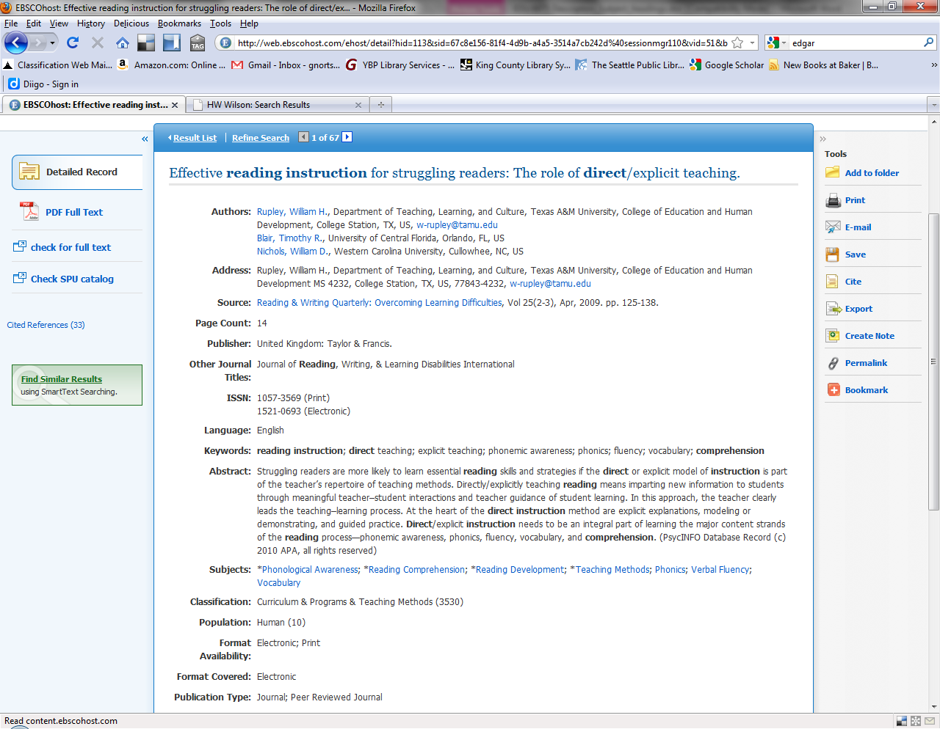

SUBJECT HEADING EXERCISE:
You can use these words to help you build an effective search. As you begin to search using keywords, keep track of your favorite descriptors by writing them in the boxes below. When you return to your search screen, use these database specific words to build a more effective search.

